CSA-0411: OPERATING SYSTEM FOR NETWORKING

**EXP 7:**

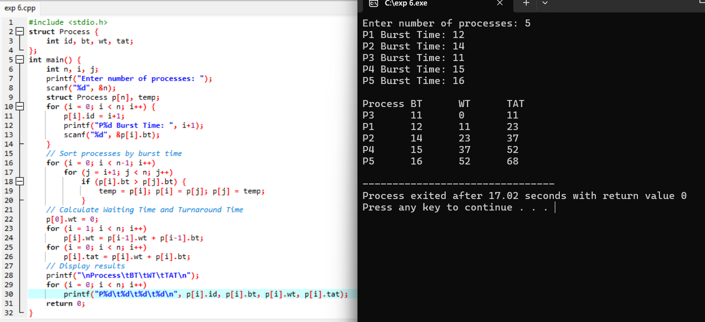

**EXP 8:**

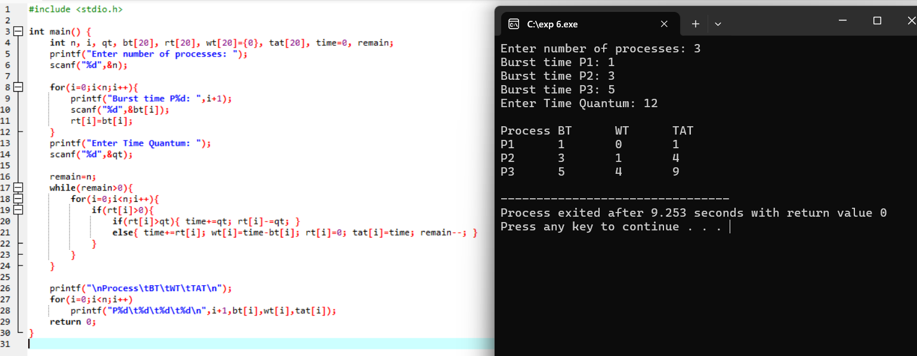

**EXP 9:**

**EXP 10:**

